Rebound Therapy
Centre of Excellence Application Form

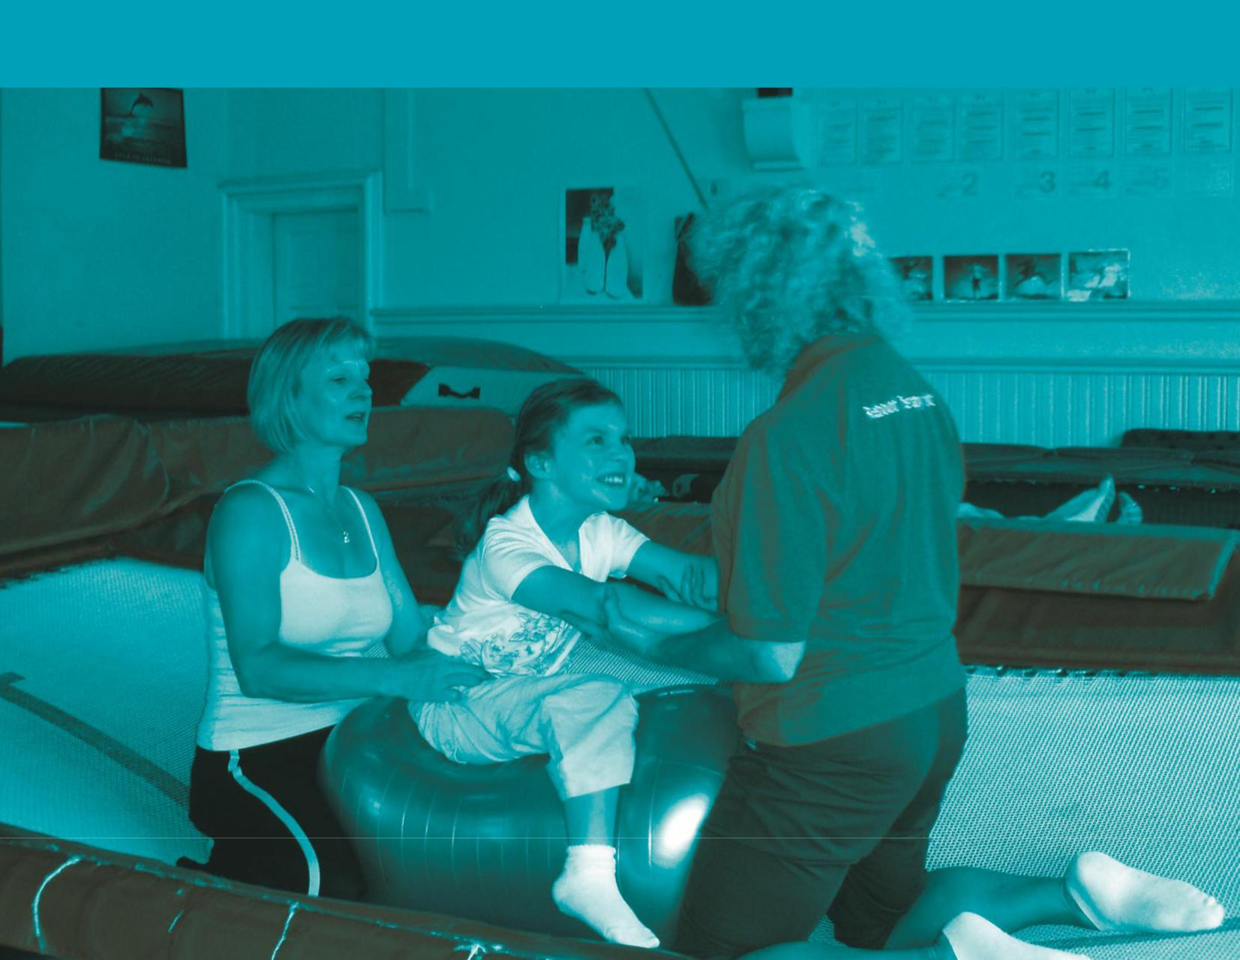

This document, when completed, should be either emailed to info@reboundtherapy.org
or posted to:
Rebound Therapy International Ltd,
Saplings, Felcourt Road, Felcourt, W Sussex, RH19 2LA, UK

This form is saved as a Word template. You may print the form, complete it longhand with hand written answers and then post it to us
OR
Complete it on a computer, save it as a Word document and email it back to us.

To complete on a PC:
Start on page 2
The text that says ‘type your text here’ will disappear when you type your own text.
The boxes (or cells) have been limited in size so you will need to ensure that you answer the question within the space provided. You may attach additional documents alongside this form if you run out of space and wish to do so.
Save your responses as a Word document (we recommend adding your name to the Filename for easy identification).
Email your saved document as an attachment.

If you have any problems please contact us on email: info@reboundtherapy.org
or Tel: +44 (0)1342 870543

Please complete all sections of this document

Application Date
14/01/2020
Venue Name
Click here to enter text.
Address line 1
Click here to enter text.
Address line 2
Click here to enter text.
Address line 3
Click here to enter text.
Post code
Click here to enter text.
Name of Applicant completing this form on behalf of their Venue
Click here to enter text.
Email address
Click here to enter text.

Please provide a synopsis on your organisation; including:
purpose, aims, values and philosophy.
Click here to enter text.
What processes do you have in place to monitor, evaluate and review the performance of your Rebound Therapy service?
Click here to enter text.

 |  |  | For how many years has your venue been providing Rebound Therapy as a regular part of your service provision?
 | Click here to enter text.
SCHOOLS / COLLEGES ONLY
Other types of venue please go to next section.
At the start of the current term, how many students attend your school?
 | Click here to enter text.
At the start of the current term,
a) How many staff are permanently employed at your school?
b) Of these staff, how many have an up to date Rebound Therapy qualification, with a Validation Number less than 3 years old?
(Further details will be required in the declaration at the end of this form).
 |  |  | Click here to enter text.
SCHOOLS / COLLEGES ONLY
Other types of venue please go to the next section.
Do all students access Rebound Therapy at least twice per week, or at least once per week if Flexi-Bounce Therapy is provided with a qualified member of staff on at least two of the other days?
If not, do you have a plan in place to introduce this?
 | a)  Details of Current  provision |  | Click here to enter text.
 | b)  Confirmed Plan to grow and develop provision (if applicable) |  | Click here to enter text.
LEISURE CENTRES, SPORTS CLUBS, TRAMPOLINE PARKS, DAY CENTRES AND OTHER VENUES ONLY
Schools and Colleges please go to next section.
How many full time permanent members of your staff have an up to date Rebound Therapy qualification, with a Validation Number less than 3 years old?
(Further details will be required in the declaration at the end of this form).
 |  |  |  | Click here to enter text.
LEISURE CENTRES, SPORTS CLUBS, TRAMPOLINE PARKS, DAY CENTRES AND OTHER VENUES ONLY
Schools and Colleges please go to next section.
How many part time, seasonal or casual members of your staff have an up to date Rebound Therapy qualification, with a Validation Number less than 3 years old?
 |  |  |  | Click here to enter text.
LEISURE CENTRES, SPORTS CLUBS, TRAMPOLINE PARKS, DAY CENTRES AND OTHER VENUES ONLY
Schools and Colleges please go to next section.
What proportion of your total staff (who work regularly with service users, it is OK to exclude admin staff and managers) are qualified Rebound Therapy trainers, with an up to date qualification?
(This means if their qualification or last refresher is more than three years old, have they revalidated, either by attending a one day refresher workshop or online Refresher course?)
For those who may require Refresher training, how and when do you plan to bring all your staff qualifications up to date?
 |  |  |  | Click here to enter text.
Are all Rebound Therapy sessions run following the approved development programme? How often is progress measured and recorded using the Winstrada
check-off sheets?
 |  | If you have students with complex needs, do you measure and record progress using the Huddersfield Functional Index in conjunction with the development plan?
 |  | Click here to enter text.
Is achievement acknowledged, celebrated and rewarded by presenting participants with the development scheme badges and certificates?
If not, do you have any other methods of acknowledging, celebrating and rewarding achievement?
Click here to enter text.
Do you write person centred objectives for participants, enabling you to observe and reflect on outcomes achieved (in addition to the HFI, if HFI is appropriate for your students)?
Please advise on these objectives giving anonymous examples. These this may include cross-curricular or communication-based targets, memory skills and interaction with peers.
Click here to enter text.
How regularly do you review these targets?
Click here to enter text.

Have all Rebound Therapy practitioners completed at least one relevant CPD workshop within the past two years?
(Examples may be: Refresher Workshop, Rebound Plus, Flexi-Bounce Therapy, Beyond Rebound, Rebound Therapy for pre-school, manual handling, hoist training, first aid)?

Please use this section to show how you are developing the knowledge and experience of your Rebound Therapy Practitioners and the benefits this has provided to your school or centre
If your staff have not completed at least one relevant CPD workshop within the past two years, please advise your plans for relevant CPD training for the coming 12 months.

Please note: details of relevant staff qualifications will be required at the end of this form.

Please also note it is perfectly acceptable for different members of staff to have completed different CPD workshops.

Click here to enter text.

Describe the process of screening as it applies to Rebound Therapy participants at your venue:
Click here to enter text.
Describe the process of screening as it applies to staff, volunteers and other helpers such as parents:
Click here to enter text.

 | Explain the process of informed consent as it applies to your Rebound Therapy participants:
 | Click here to enter text.
 | Identify three pieces of information that need to be collected about a participant prior to participation in a Rebound Therapy session
a) | Click here to enter text.
b) | Click here to enter text.
c) | Click here to enter text.
 | Explain the importance of displaying sensitivity and empathy to a participant and their parent/carer
Participant:
Click here to enter text.
Parent/carer:
Click here to enter text.
 | Describe how to determine which methods of collecting information are appropriate to the individual participant
Click here to enter text.
 | List and describe the six contra-indications specific to Rebound Therapy
1) | Click here to enter text.
2) | Click here to enter text.
3) | Click here to enter text.
4) | Click here to enter text.
5) | Click here to enter text.
6) | Click here to enter text.
 | Describe three precautionary measures which could be taken for a participant whose conditions indicate increased risk
a) | Click here to enter text.
b) | Click here to enter text.
c) | Click here to enter text.
 | Give three examples of how participant information could affect the planning of a Rebound Therapy session
a) | Click here to enter text.
b) | Click here to enter text.
c) | Click here to enter text.
 | If you provide a service for students with profound and complex needs, do you liaise with a physiotherapist or other professional with knowledge of the students’ condition in order to help provide a safe and effective programme?
 | Click here to enter text.
 | Do you have a medical questionnaire and consent form completed for every one of your students? How often is this checked and renewed?
Click here to enter text.
How many trampolines does your venue have?
Please advise more about your facility, considering the following:
Folding or sunken trampolines (or both), do you use end decks for any folding trampolines? How often is your equipment checked for faults or damage? How often is your equipment serviced by an approved trampoline servicing organisation?
Click here to enter text.

How many spotters are present at your Rebound Therapy sessions?
It may be useful, subject to your circumstances, to discuss how this may vary according to individual participant needs.
Click here to enter text.
Please provide a testimonial report about the benefits of Rebound Therapy in your school or centre:

If you need additional space, please feel free to add additional pages. The easiest way to do this is to add additional attachments to your email when returning this form to the ReboundTherapy.org office.
Click here to enter text.
 | DECLARATION – STAFF QUALIFICATIONS
Please list the full names and Validation Numbers of all your  Rebound Therapy Practitioners  who have an up to date qualification.  Providing the Validation Number for candidates is much easier than scanning certificates, although if you already have electronic copies of certificates on file, you may email these to us.  This process enables us to locate and verify the training records of your Rebound Therapy Practitioners.  If any members of staff have misplaced their certificates, please ask them to email info@reboundtherapy.org for advice.  You may continue on a separate page if necessary. | Click here to enter text.
Please list the full names and Validation Numbers of all your  Rebound Therapy practitioners who have also completed the  Rebound Plus add-on module  with validation to Grade 8.  You may continue on a separate page if necessary. | Click here to enter text.
Please list the full names and Validation Numbers of all your Rebound Plus practitioners who have completed the  Beyond Rebound  add-on module  with validation to Grade 10.  Please list the full names and Validation Numbers of all your staff who have completed the  Flexi-Bounce Therapy  training programme. | Click here to enter text.
 | Is there any additional information you would like to provide to support your Rebound Therapy Centre of Excellence application?
Click here to enter text.

I confirm that the information I have provided is correct and accurate.
I confirm that I am authorised to represent my venue by submitting this application.
Applicant signature: | Click here to enter text. | Date: | Click here to enter text.
Joint applicant
(if applicable)
FOR OFFICE USE
BY REBOUND THERAPY ONLY

APPLICATION RECEIVED ON…………………
NOTES:

ASSESSED ON……………………………..
CENTRE OF EXCELLENCE STATUS HAS BEEN ACHIEVED YES / NO
FEEDBACK SENT YES / NO
FURTHER EVIDENCE REQUIRED YES / NO

Assessor’s signature: | Click here to enter text. | Date: | Click here to enter text.

