

The UK based founding organization, worldwide federation
and international consultancy for Rebound Therapy

Tel: 0330 1225684 E-mail: info@ReboundTherapy.org Web: www.ReboundTherapy.org

Rebound Therapy One day Refresher / Validation workshop

This workshop is recommended for:

- Those who have previously completed the Rebound Therapy course and would like to refresh and update their knowledge and teaching skills.
- Those who have completed the approved basic level school or centre specific course and would like to upgrade to the standard portable qualification
- Those who have completed a special needs trampolining course run by a recognised provider and who would like to refresh and learn Rebound Therapy skills.

Course content: Manual handling of trampolines,
Benefits and contra-indications,
Practical demonstrations of Rebound Therapy exercises and techniques,
Programmes for defined special needs,
Supporting techniques,
Use of Winstrada development and award programme,
Role play with group feedback

Candidates will each receive a copy of the ‘HFI for Winstrada’ manual for measuring outcomes.
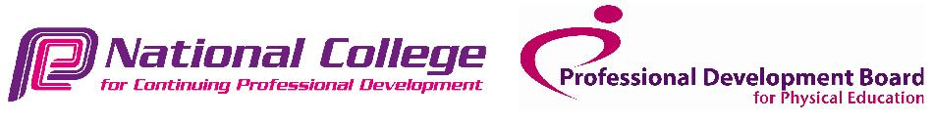
Cost: £168 (plus VAT) per candidate

It is recommended that all Rebound Therapy trainers attend a one-day refresher workshop every three years.

- - - - - - - - - - - - - - - - - - - - - - - - - - - - - - - - - - - - - - - - - - - - - - - - - -

APPLICATION FORM

ONE - DAY REBOUND THERAPY REFRESHER / VALIDATION WORKSHOP

Date: Friday 23rd January 2026 Times: 9.00am to 3.30pm Cost: £168 plus VAT = £201.60
Venue: Chadsgrove Sports College, Meadow Road, Catshill, Bromsgrove, B61 0JL

Name:…………………………………………...........……………………DOB:………………............….

Address:…………………………………………………………….......................………………………...

Phone:……………………………....…………Email:………………..................…………………………

Occupation...…………...............…...………Organisation represented:…...............……….......………….

No. of places required:…............. Payment made by: Cheque........BACS........Online........Invoice reqd...........

Please return this completed application form
together with a copy of your original Rebound or SN Trampolining course certificate to:
Rebound Therapy.org, Saplings, Felcourt Road, Felcourt, W. Sussex, RH19 2LA
Reservations can only be accepted once full fee has been received.
- If paying by cheque, please make it payable to Rebound Therapy International Ltd.
- If paying online, please Click here or paste the following address into your browser:
- https://www.reboundtherapy.org/courses/online_app
- Or BACS payments to: Nat West Bank 60-07-17 42774802

VAT registration number 289285641
Rebound Therapy International Ltd registered in England. No. 11224372

