

The UK based founding organization, worldwide federation
and international consultancy for Rebound Therapy

Tel: 0330 122 5684 E-mail: info@ReboundTherapy.org Web: www.ReboundTherapy.org

Rebound Plus
TWO-DAY CERTIFICATED COURSE
The Rebound Plus course is a two-day add-on module for those who have already completed a genuine Rebound Therapy Practitioner training course.
It is designed to equip candidates to help their more able students progress beyond Rebound Therapy and start the transition into mainstream trampolining exercises.
Dates and times: Monday 12th and Tuesday 13th October 2026
9.00am to 3.30pm both days

Venue: Chadsgrove Sports College, Meadow, Road, Catshill, Bromsgrove, B61 0JL

Cost: £367 (plus VAT) per person = £440.40

Payment options: Cheque, Online or BACS see details below

This course is step 2 of 3 on the 3-Step Pathway to recreational trampoline coaching.

Please note the following: This course is not suitable for those who are pregnant. This course is not intended for recapping of skills previously learned. If you need to recap on anything from your previous Rebound Therapy course you should attend a one-day Rebound Therapy refresher workshop before booking onto this course.

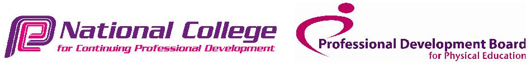

-----------------------------------------------------------------------------------------------------------------------------------------------------------------

Application Form for open Rebound Plus Training Course - 12th and 13th October 2026

Name:………………………………………………………………DOB:………………………..……….

Address:…………………………………………………………………………………..………………...

Phone:……………………………….……………Email:……………….…………………………………

Occupation...…………………………………………………………………………………

Organisation represented:……………………………………………………………………

No. of places required:…............. Payment made by: Cheque........BACS........Online........Invoice reqd...........

Please return completed application form, and a copy of your Rebound Therapy course certificate to:

ReboundTherapy.org, Saplings, Felcourt Road, Felcourt, West Sussex, RH19 2LA

Reservations can only be accepted once full fee has been received.
- If paying by cheque, please make it payable to Rebound Therapy International Ltd.
If paying online, please Click here or paste the following address into your browser: https://www.reboundtherapy.org/courses/online_app
- Or BACS payments to: Nat West Bank 60-07-17 42774802.

VAT registration number 289285641
Rebound Therapy International Ltd registered in England at the address shown. Registration number 11224372

