The UK based founding organization, worldwide federation
and international consultancy for Rebound Therapy

Tel: 0330 122 5684 E-mail: info@ReboundTherapy.org Web: www.ReboundTherapy.org

Saplings, Felcourt Road, Felcourt, W.Sussex, RH19 2LA

TWO-DAY CERTIFICATED COURSE IN REBOUND THERAPY

Alternative approaches to movement for people with Special Needs

Dates and times: Thursday and Friday 24th and 25th October 2024
9.00am to 3.30pm both days.

Venue: InFocus Charity, Topsham Road, Countess Wear, Exeter, EX2 6HA

Cost: £294 (plus VAT) per person

Payment options: Cheque, Online or BACS see details below

Course Outline: Safety Aspects; Appraisal of personal skills; Development and award programmes; Programmes for defined special needs; Problem solving – practical simulations.
Candidates will each receive a copy of the ‘HFI for Winstrada’ manual for measuring outcomes.

This is a wide-ranging course, encompassing a variety of professional disciplines. We welcome those involved in various caring professions – specifically:
Teachers, Teaching assistants, Physiotherapists, Occupational Therapists, Speech and Language Therapists, Nurses, Parents, Carers and Health workers. Also Trampoline Coaches.

For more information, please contact ReboundTherapy.org using the contact details at the top of this page.

- - - - - - - - - - - - - - - - - - - - - - - - - - - - - - - - - - - - - - - - - - - - - - - - - - - - - - - - - - - - -
APPLICATION FORM

REBOUND THERAPY COURSE Exeter 24th and 25th October 2024 Fee: £294 plus VAT = £352.80

Name:………………………………………………………………DOB:………………….

Address:……………………………………………………………………………………...

Phone:………………………………………Email:…………………………………………

Occupation...…………………………………………………………………………………

Organisation represented:……………………………………………………………………

No. of places required:…............. Payment made by: Cheque........BACS........Online........Invoice reqd...........

Please return completed application form to ReboundTherapy.org at: Rebound Therapy International Ltd, Saplings, Felcourt Road, Felcourt, West Sussex, RH19 2LA.
Reservations can only be accepted once full fee has been received.
- If paying by cheque, please make it payable to Rebound Therapy International Ltd.
- If paying online, please Click here or paste the following address into your browser:
https://www.reboundtherapy.org/courses/online_app
- Or BACS payments to: Nat West Bank 60-07-17 42774802.

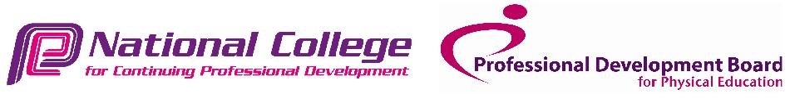VAT registration number 289285641
Rebound Therapy International Ltd registered in England. No. 11224372

